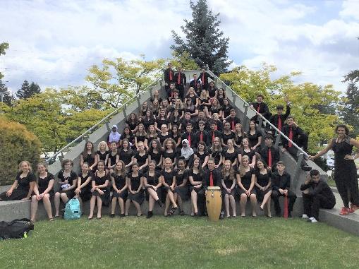
School’s Out Day
Tillicum Middle School
Choir Camp
Friday, November 9, 2018
8:00 a.m. – 4:00 p.m.

What will your children be doing when there is no school on Friday, November 9, 2018? Why not have them join for us at Tillicum Middle School for a fun choir camp. TMS Choir day camp for K-5 students will be led by the TMS Choir students under the guidance of TMS choir director, Julia Meyering. This event is a fundraiser for the choir’s festivals and events this school year!

Where: Tillicum Middle School Commons and Choir Room
Hours: 8:00 am - 4:00 pm
Performance: 3:30 pm campers will perform for families and parents
Cost: $50/day per camper. Additional siblings are $20
Camp includes: snacks, games, crafts and singing!

Please make sure to provide a sack lunch and a water bottle for your child. TMS choir will provide snacks.

Participants should wear comfortable shoes and clothing.

To register your children, please e-mail Tillicumchoirfund@gmail.com.
Please tell us the following:
Children’s names
School name
Grade

Payment can be made by cash or check on the day of the camp at the check in table.

