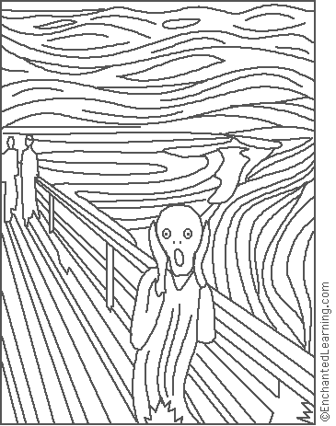
Edvard Munch: The Scream
Edvard Munch (December 12, 1863-Jan. 23, 1944) was a Norwegian expressionist painter. Munch's "The Scream" was painted in 1893.

